Castle Boys’ Soccer Middle School Soccer Camp
June 22,23, and 24 6-8pm @ The Castle Soccer Fields

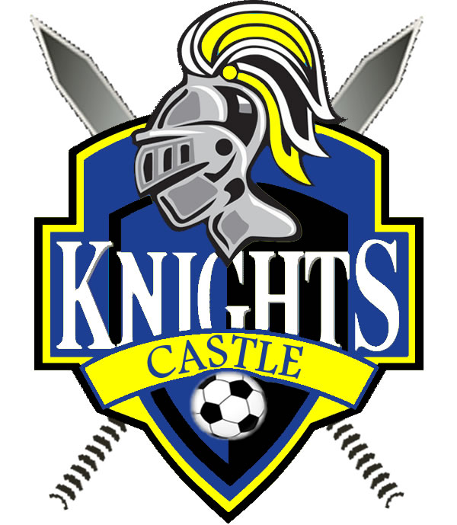

This three day camp will officially begin the cub soccer season. If you’re interested in trying out for the cub soccer teams (6th through 8th graders from Castle North and Castle South), this camp will give you the opportunity to meet the coaches, fellow players, and learn from the high school coaches.

Contact Coach Reiter at mreiter@warrick.k12.in.us with any questions!

Castle Boys’ Soccer Middle School Camp
June 22, 23, and 24 6-8pm @ Castle High School

Camper’s Name: ________________________________

Parent/Legal Guardian: ____________________________

Payment ($40): Cash Check:#___________
*Make checks payable to Castle Soccer Camps

Email Address: ___________________________________

Phone #: ________________________________________

WE AS PARENTS OR GUARDIANS HEREBY GIVE PERMISSION FOR OUR SON TO PARTICIPATE IN THE CASTLE HIGH SCHOOL SOCCER CAMP AND ACKNOWLEDGE THE FACT THAT HE IS PHYSICALLY ABLE TO PARTICIPATE IN CAMP ACTIVITIES. WE UNDERSTAND AND AGREE THAT MIKE REITER AND HIS STAFF SHALL PROVIDE ONLY EMERGENCY MEDICAL TREATMENT FOR ANY INJURIES SUFFERED AND I/WE ASSUME FULL RESPONSIBILITY FOR ALL MEDICAL EXPENSES INCURRED AS A RESULT OF PARTICIPATING IN THIS CAMP.
Parent/Legal Guardian Signature: ____________________
Mail to : Mike Reiter
3666 Katalla Dr.
Newburgh, IN 47630

